Main.cpp :

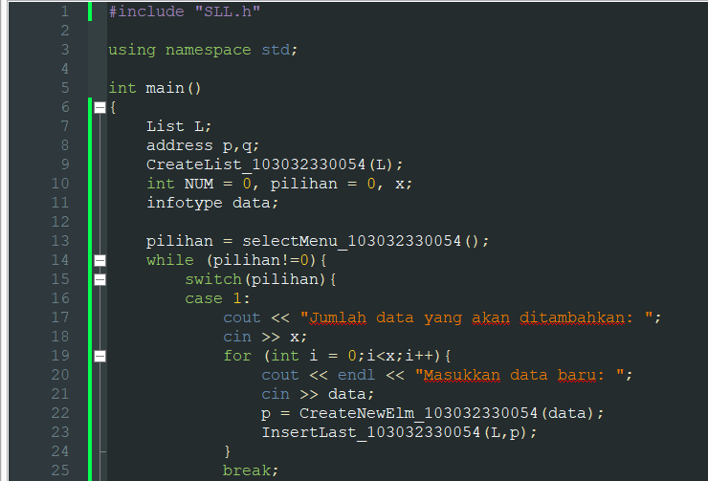

SLL.cpp:

SLL.h:

Hasil:

